2019 Dragon Boat Team Registration

Team name | Click here to enter text.
Organization/company | Click here to enter text.
Preferred t-shirt colour* (colours are not guaranteed) | Click here to enter text.
Name to appear on boat banner (eg. company/organization) | Click here to enter text.
Social media links (optional, for promotional use) | Click here to enter text.
*see page 3 for t-shirt colour options
Team captain name | Click here to enter text.
E-mail | Click here to enter text.
Phone | Click here to enter text.
Mailing address | Click here to enter text.

Alternate contact name | Click here to enter text.
E-mail | Click here to enter text.
Phone | Click here to enter text.
Mailing address | Click here to enter text.

Pledge captain | Click here to enter text.
E-mail | Click here to enter text.
Phone | Click here to enter text.
Mailing address | Click here to enter text.

See reverse page for payment instructions…

Payment Options
- Registration fee: $1000 per team.
  - $250 deposit due by May 1, 2019
  - Remaining installment of $750 due June 1, 2019
- Payment options:
  - Credit card, in office or by phone
  - Cheque made payable to Clean Annapolis River Project
  - Online payment through CARP’s online store, annapolisriver.ca

Contact information
Dragon Boat Race Coordinator: Karen Morley
k.morley2@icloud.com
Office contact: Katie McLean, (902)-532-7533 ext. 6, carp@annapolisriver.ca

Next steps:
Team captains will receive a package with all required forms. Once received this will allow you to:
- Collect pledges (pledge forms provided to Pledge Caption), due on race day
- Complete t-shirt order form, due June 1
- Complete participant waiver (electronic form, print form or online form)
- Team captains will receive an additional information and instruction package; heat times TBD closer to the event date

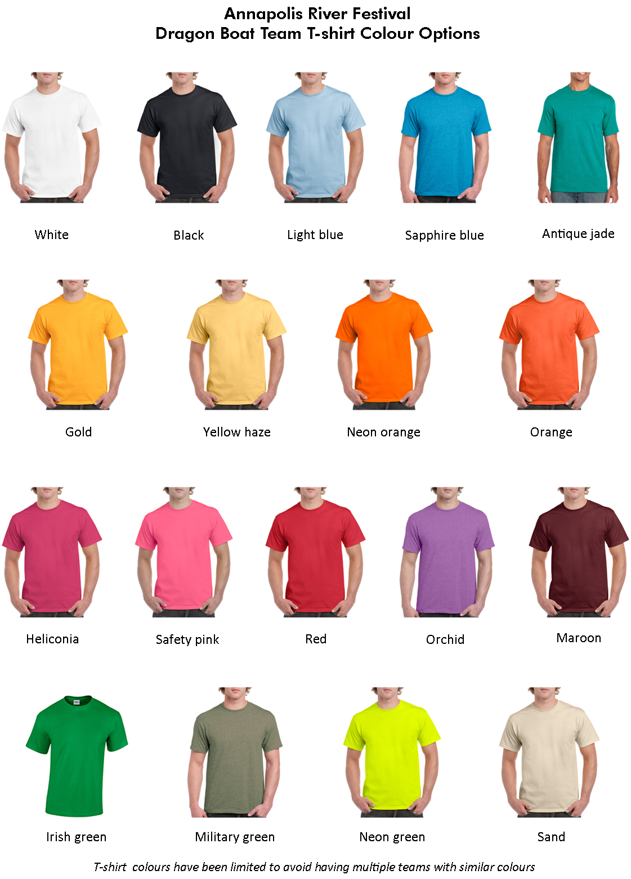
Berry

